The following text is for test items 1 – 5.
Last year, I was 18 years old. I had just graduated from high school, and I wanted to continue my studies in Yogyakarta. I had lived with my family in Cirebon for my whole life, so living on my own in Yogyakarta was going to be a new experience for me.
I traveled to Yogyakarta by train. Before arriving at the station, I wasn’t sure how to check in because everything was new to me. Luckily, a security guard helped me and showed me what to do. After that, I boarded the train and found my seat.
During the trip, I listened to music and enjoyed the ride. After five hours, I finally arrived in Yogyakarta. I was excited to begin my new life and adventures in the city.

- The text tells us about the writer’s experience of ….
- graduating from high school
- living on his own in Yogyakarta
- living in Cirebon for his whole life
- having trip of his own to Yogyakarta

- What did the writer do on the train?
- He began his new life in Yogyakarta.
- He appreciated his adventures.
- He listened to the song.
- He enjoyed his trip.

- What is main idea of the second paragraph?
- The writer checked in for train in the railway station.
- The security guard helped the writer to board the train.
- The writer arrived at the station and helped the security.
- The security guard helped the writer to look for his seat.

- Why did writer need the security guard’s help in the railway station?
- Because the security guard was kind.
- Because the writer got no seat on the train.
- Because the writer has never done it before
- Because the security guard boarded the same train.
The following text is for test items 5 – 7.
Eating healthy is good for your body. Here are some easy tips for teenagers to eat better:
- Eat More Fruits and Vegetables
Try to eat fruits like apples or bananas and vegetables. They help you grow and stay strong.
- Drink Water
Water is the best drink. Try to drink 6-8 glasses of water every day.
- Eat Whole Grains
Foods like brown rice and whole-wheat bread are good for you. They give you more energy than white bread.
- Choose Healthy Snacks
When you are hungry, eat healthy snacks like fruit or yogurt. Avoid too much candy or chips.
- Avoid Sugary Drinks
Drinks like soda have a lot of sugar. It’s better to drink water or juice.
Follow these tips to stay healthy and feel good every day!

- By reading the article, people will ….
 | Effects | True | False
 | understand about how to arrange delicious menu |  | v
 | get informed about many kinds of healthy snack |  | v
 | get well informed about what to do to eat better | v

- Among the followings, which one should we avoid to consume?
- Fruits.
- Soda.
- Water.
- Vegetables.

- Which of the following descriptions are in line with the text?
- Drinking sugary drinks is better than drinking water.
- Brown rice gives us more energy than white bread.
- We should drink at least 6 glasses of water every day.
- We need to consume fruit, yogurt, candy or chips daily.
The following text is for test items 8 – 11.
Last month, I joined a camping trip with my classmates. It was my first time sleeping in a tent, so I felt both nervous and excited. We went to a camping ground near a forest, about two hours from our school.
When we arrived, we worked together to set up the tents. At first, I didn’t know how to do it, but my friends showed me the steps. After the tents were ready, we cooked instant noodles and shared them happily.
At night, we sat around the campfire. We sang songs, told funny stories, and enjoyed the cool air. I looked up at the sky and saw many stars. It was one of the most unforgettable nights in my life.

- The text mainly tells us about the writer’s experience of …
- joining a camping trip
- setting up a tent at home
- singing songs with his family
- cooking instant noodles at school

- What did the writer do at the camping ground?
 | What the Writer Do | True | False
 | He cooked instant noodles. | v
 | He studied with his classmates. |  | v
 | He sang songs around the campfire. | v

- What is the main idea of the second paragraph?
- The writer learned how to set up a tent.
- The writer cooked noodles with his friends.
- The writer arrived at the camping ground.
- The writer shared stories around the campfire.

- Why did the writer feel nervous at the beginning of the trip?
- Because he didn’t like camping.
- Because his friends didn’t help him.
- Because he had never slept in a tent before.
- Because the camping ground was far from school.

The following text is for test items 12 – 15.
Every weekday, I wake up at 6 a.m. I make my bed and then take a shower. After that, I eat breakfast with my family. At 7 a.m., I go to school by bicycle.
At school, I study many subjects such as English, Math, and Science. During the break, I usually chat with my friends or buy snacks at the canteen. My favorite subject is English because I enjoy learning new words.
In the afternoon, I return home and help my mother with housework. In the evening, I do my homework and read a book before going to bed at 9 p.m.

- The text mainly tells us about …
- the writer’s hobbies at home
- the writer’s favorite subject
- the writer’s daily activities
- the writer’s trip to school

- What does the writer usually do during the break at school?
- He reads a book.
- He studies English.
- He helps his mother.
- He chats with his friends.

- Which of the following statements are TRUE based on the text?
- The writer eats breakfast alone.
- The writer goes to bed at 9 p.m.
- The writer goes to school by bicycle.
- The writer studies only English at school.

The following text is for test items 15 – 17.
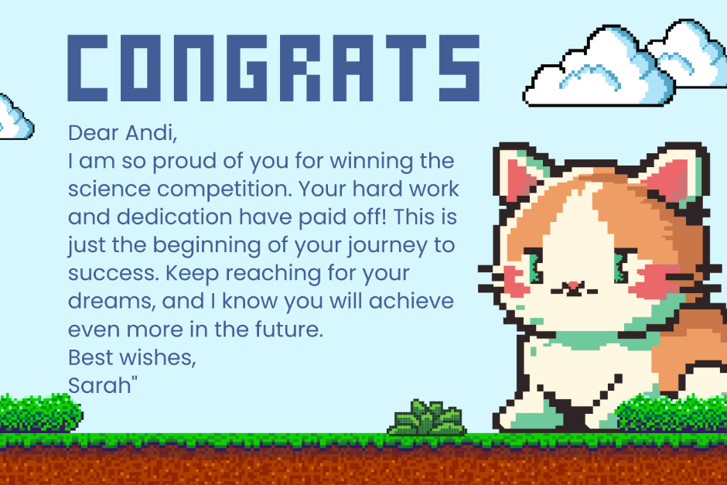
- Sarah writes the text to ….
- encourage Andi to win a science competition
- motivate Andi to get more success in the future
- congratulate Andi on winning a science competition
- give support to Andi on the beginning of his journey

- Sarah sends the card when Andi ....
- gets ready to participate in competitions
- has got success in a science competition
- has his preparation for a science competition
- has received an invitation to a science competition

- From the text we can conclude that Andi ....
- is a very proud student
- has less commitment
- puts in a lot of effort
- lacks of confidence
The following text is for test items 18 – 20.
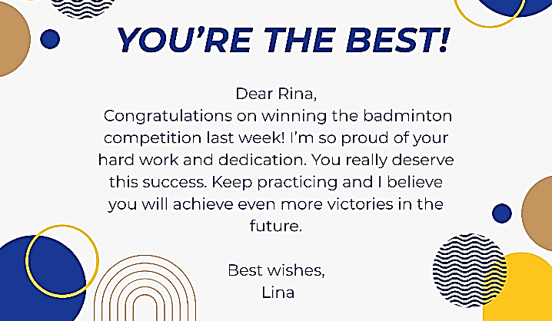

- Lina writes the text to ….
- motivate Rina to join a badminton competition
- remind Rina to practice badminton every day
- congratulate Rina on her achievement
- invite Rina to play badminton together

- Lina sends the card when Rina ….
- is preparing for a badminton competition
- has won a badminton competition
- is practicing badminton at school
- has joined a badminton club

- From the text we can conclude that Rina ….
- is a lazy student
- has no interest in sports
- lacks confidence in hersel
- puts in effort and dedication

The following text is for test items 21 – 23.
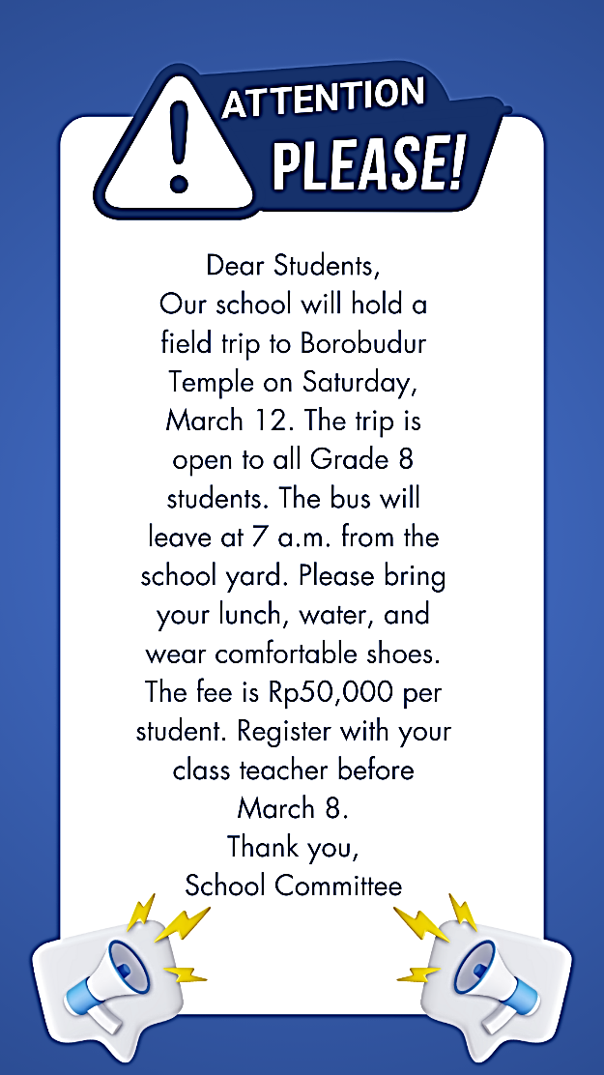
- The writer writes the text to ….
- inform students about a science competition
- remind students to do their homework
- invite students to join a school trip
- tell students about new teachers

- Why should students wear comfortable shoes?
- Because they will walk around the temple.
- Because they will dance on the temple stage.
- Because they will play football at the temple field.
- Because they will run in a marathon around the temple.

- Having read the text, the readers will probably ….
- know the registration deadline
- know the date and place of the trip
- understand how to prepare for a competition
- understand the importance of studying history

The following text is for test items 24 – 26.

- The writer writes the text to ….
- inform students about a field trip
- announce a Science Fair event
- tell students about new teachers
- request students to do homework

- Why does the writer encourage students to participate in the Science Fair?
    - To exhibit their science skills and creativity.
    - To get something learned from the fair.
    - To complete their science homework.
    - To showcase their artistic skills.

- Having read the text, the readers will probably ….
 | Effects | True | False
 | understand the importance of studying science |  | v
 | know about a fun event and how to participate | v
 | know the deadline for submitting project ideas | v

The following text is for test items 27 – 30.
I tried my best, I gave my all,
But in the end, I took a fall.
The prize went to someone new,
And I felt sad, it’s true.

I practiced hard, I worked each day,
But sometimes things don’t go your way.
I didn’t win, but that’s okay,
There’s always another day.

I learned a lot, I’ll grow from here,
I’ll try again, without fear.
Winning isn’t everything, I know,
It's about the courage to learn and grow.

- The writer of the poem is likely someone who ….
- won a competition
- experienced failure
- got a prize for winning
- worked hard for money

- What did the writer feel about his loss?
- Angry.
- Happy.
- Thankful.
- Disappointed.

- What is the message of the poem?
- Never forgive yourself for failure.
- Being the winner is the only option.
- Train harder and be hard on yourself.
- Learn from failure and never give up easily.

- What is the most suitable title for the poem above?
- The Joy of Winning
- A Beautiful Day in Life
- Falling, Yet Rising Again
- The Power of Friendship

